**Practical 7**

**Wireless network hacking, cloud computing security, cryptography:**

1. Using Cryptool to encrypt and decrypt password.

Perform encryption and decryption of text by using cryptool 2

Using the cryptool 2 tool perform the following

a) Ceaser Cipher

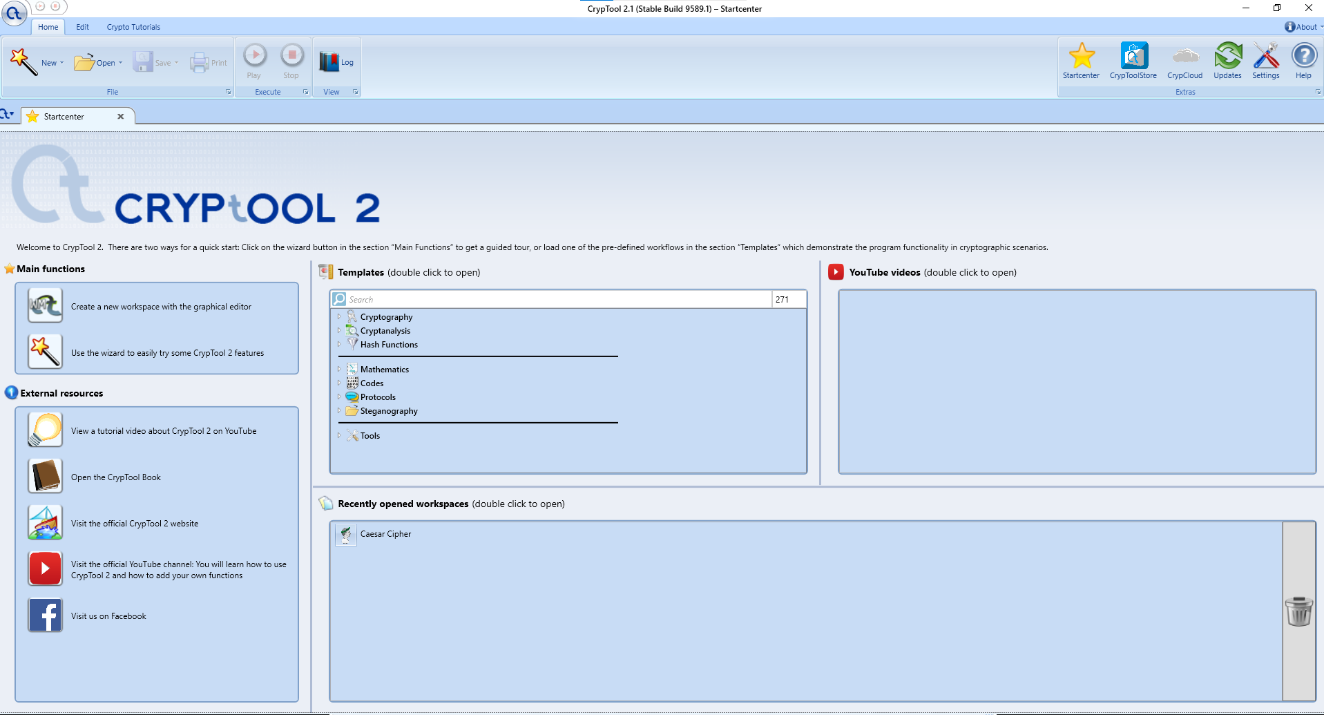

**Main function Click on wizard**

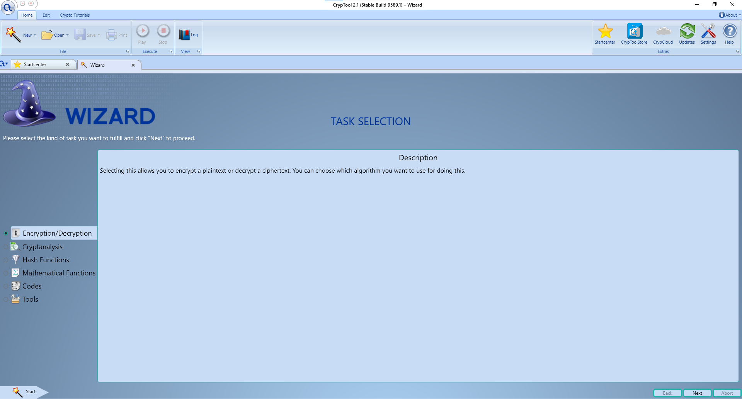

**Select Task Encryption and decryption**

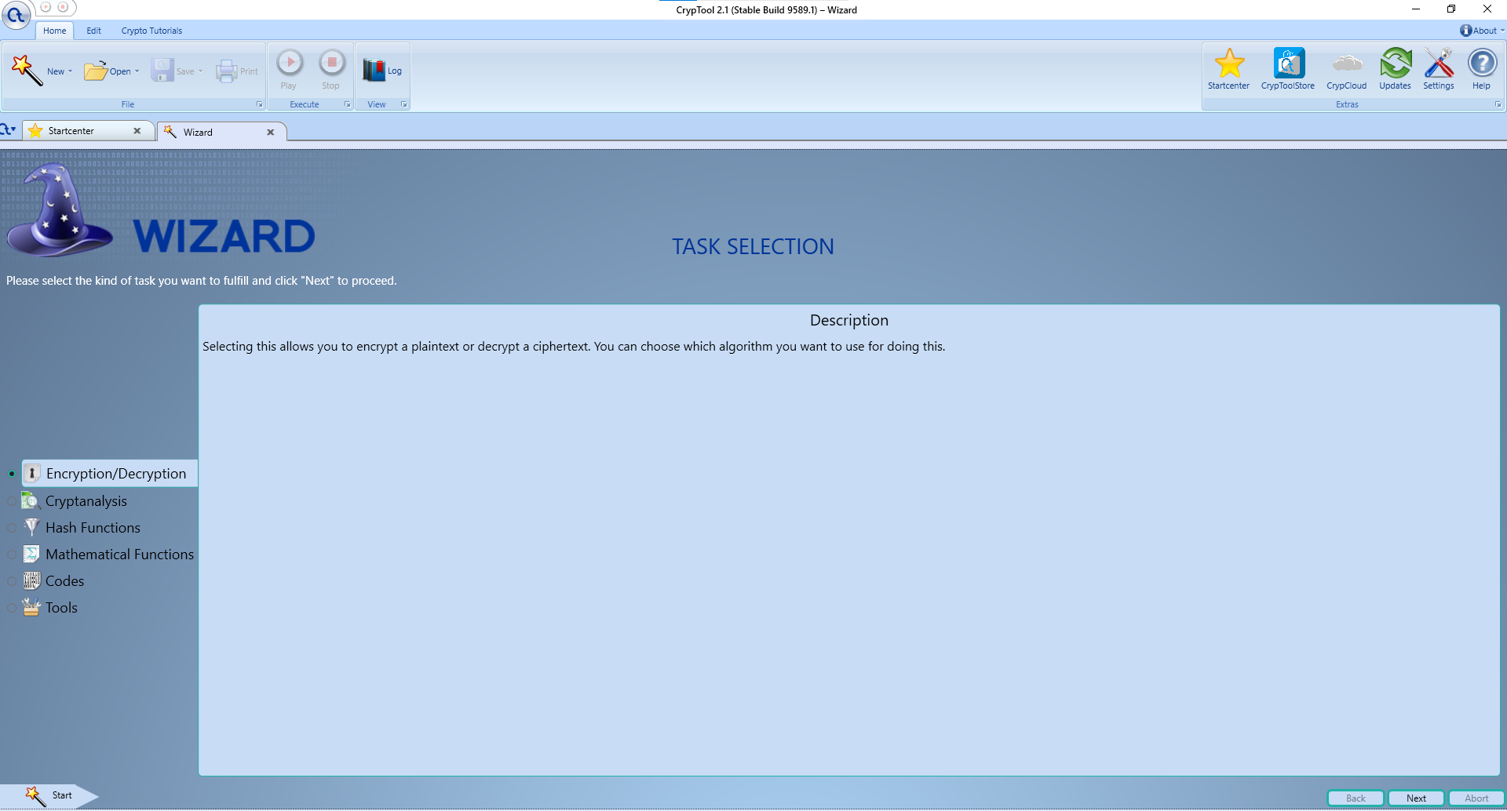

**Select classic Encryption /decryption**

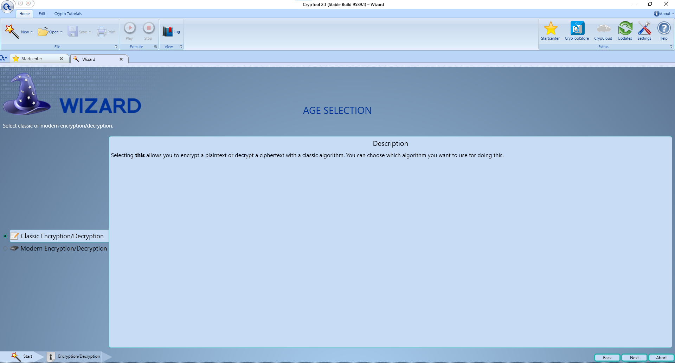

**Select Caesar cipher**

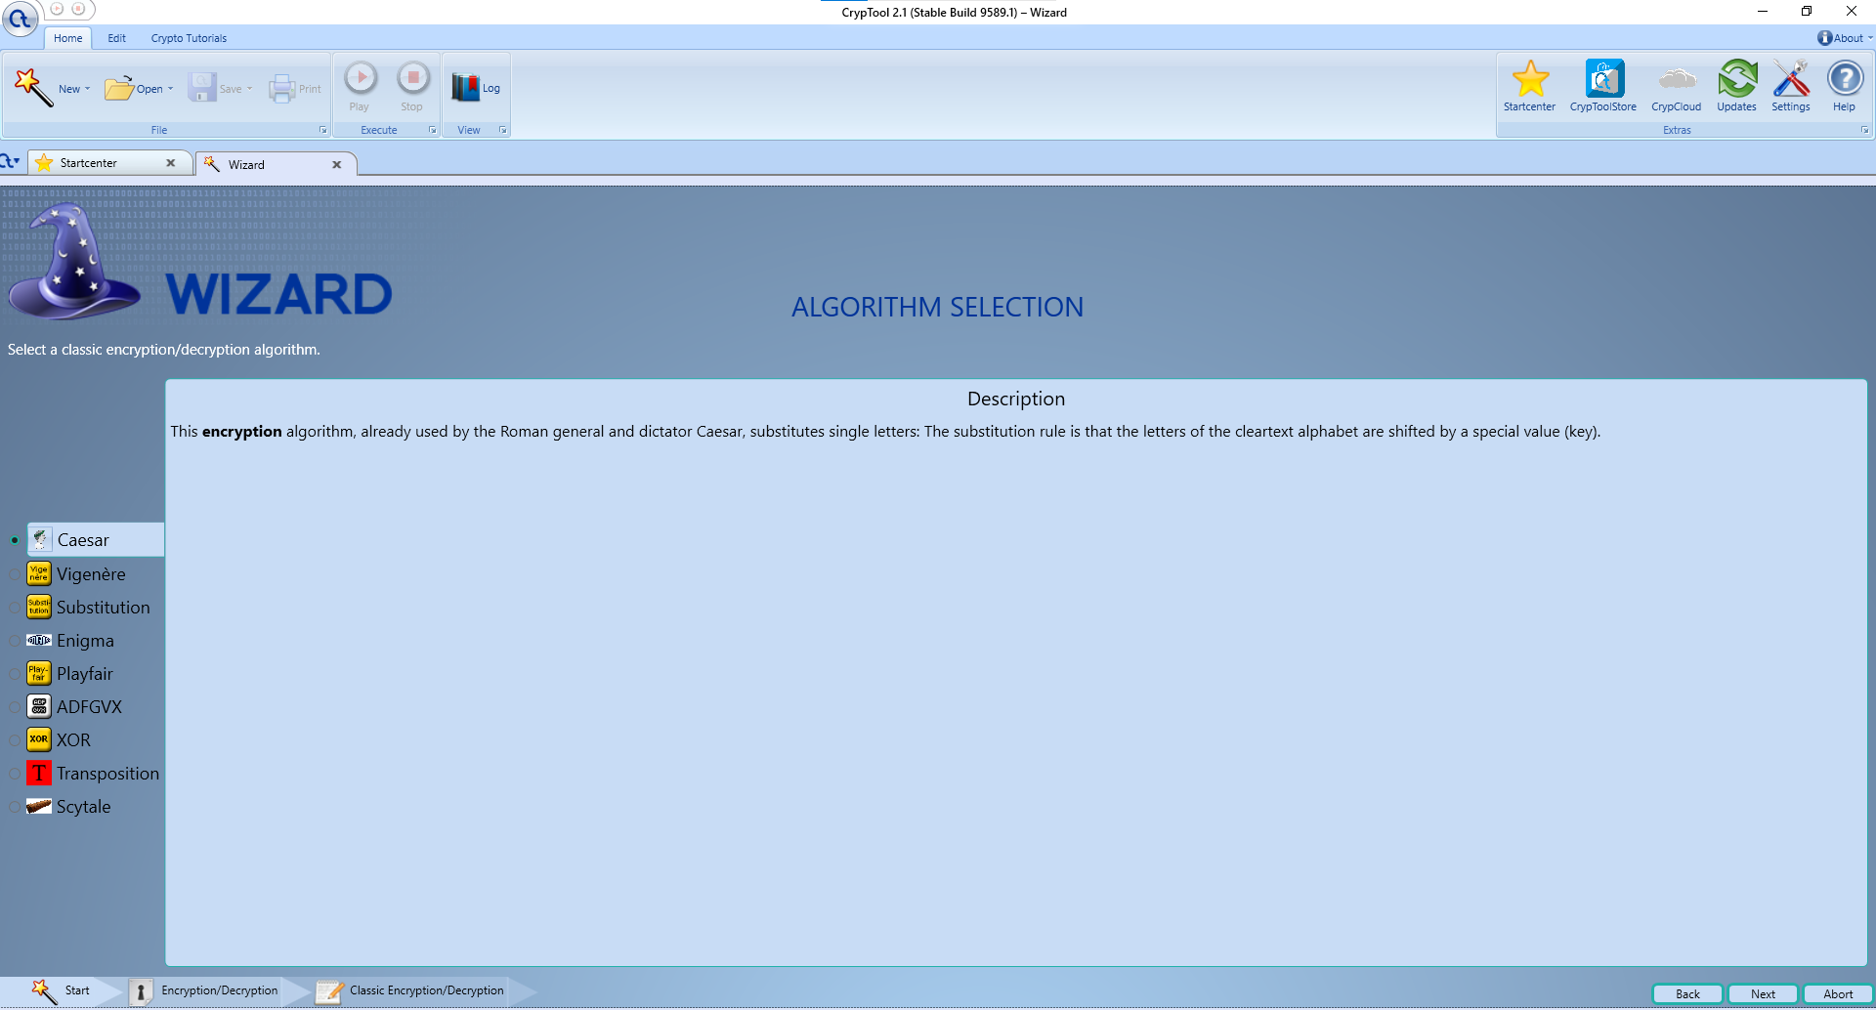

**Enter message in input-for eg. Hi how r u, select encrypt**

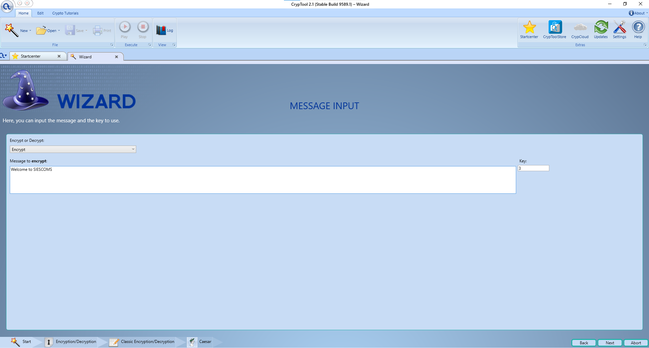

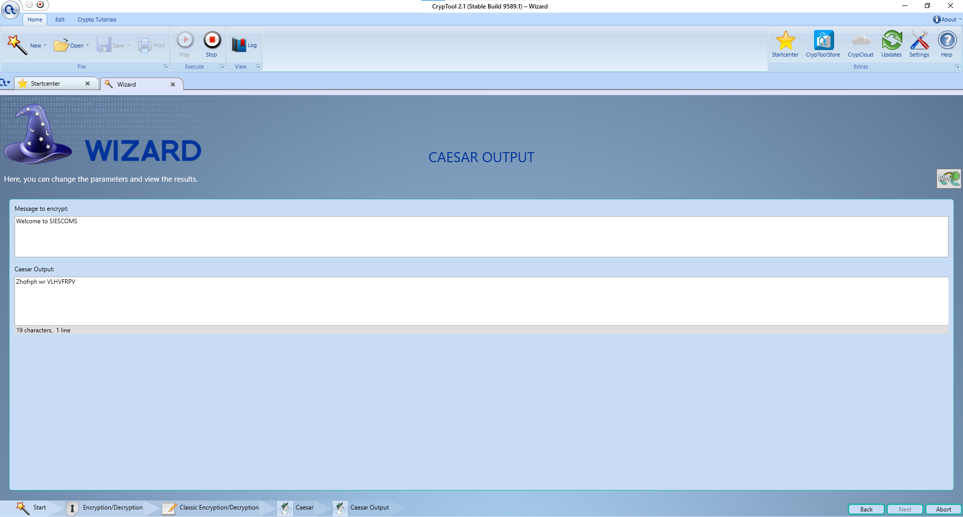

**Caesar cipher: decryption output**

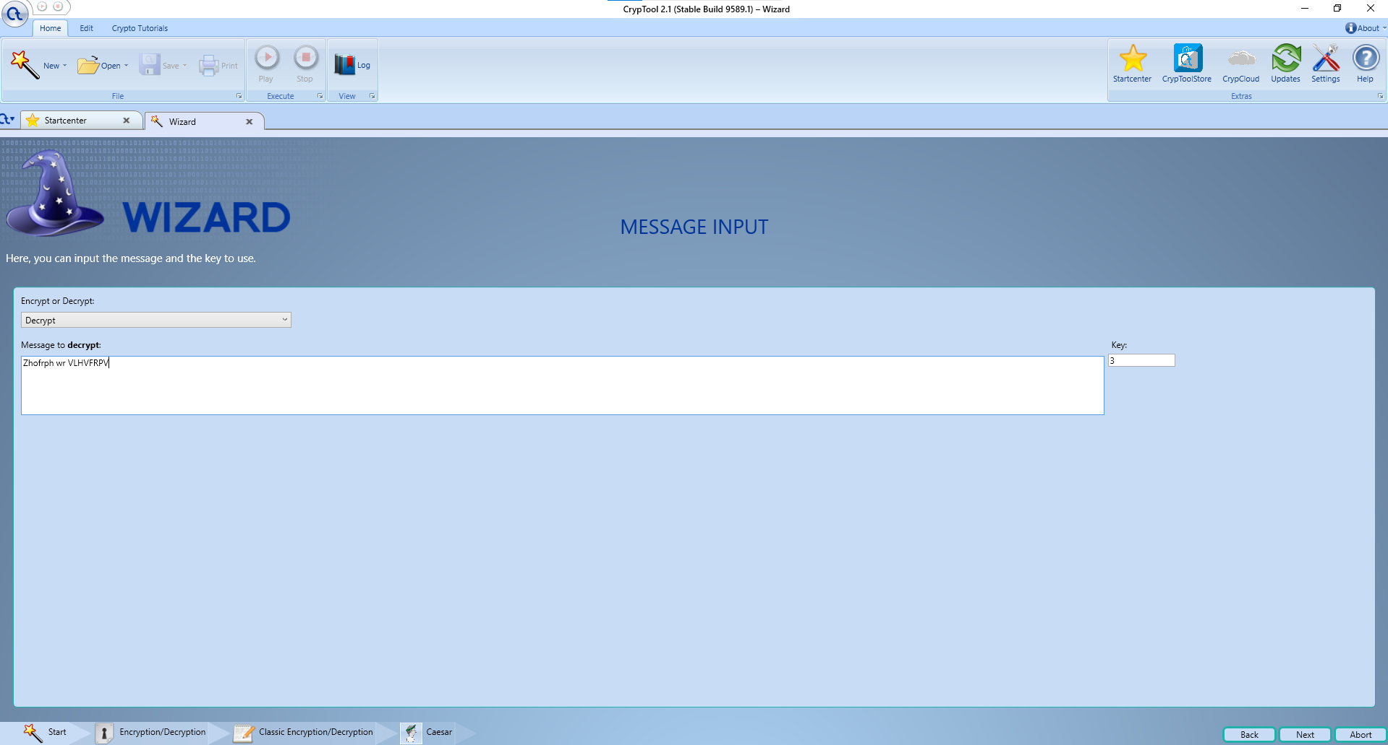

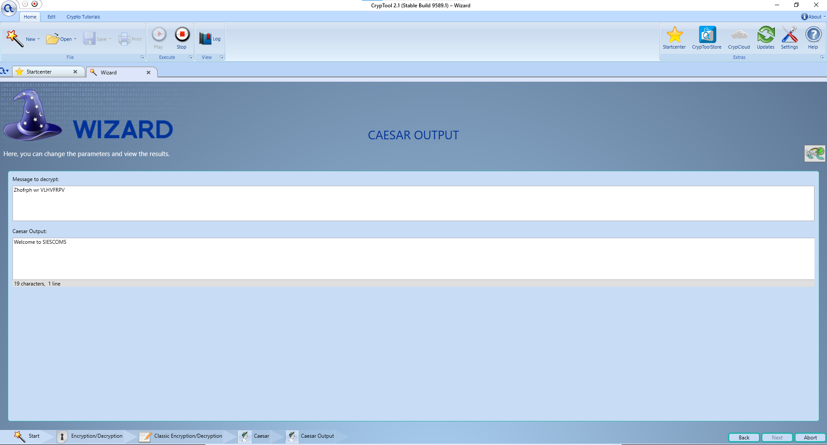

b) Substitution Cipher

**Select Substitution Cipher**

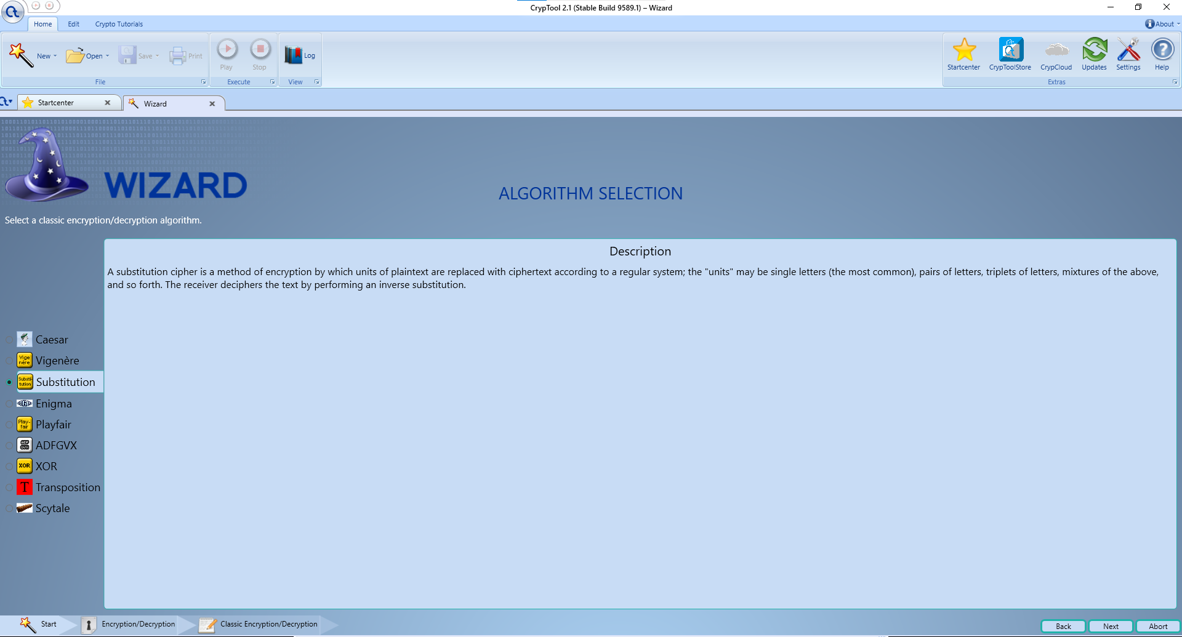

**Enter message in input-for eg. Hi how r u, select encrypt**

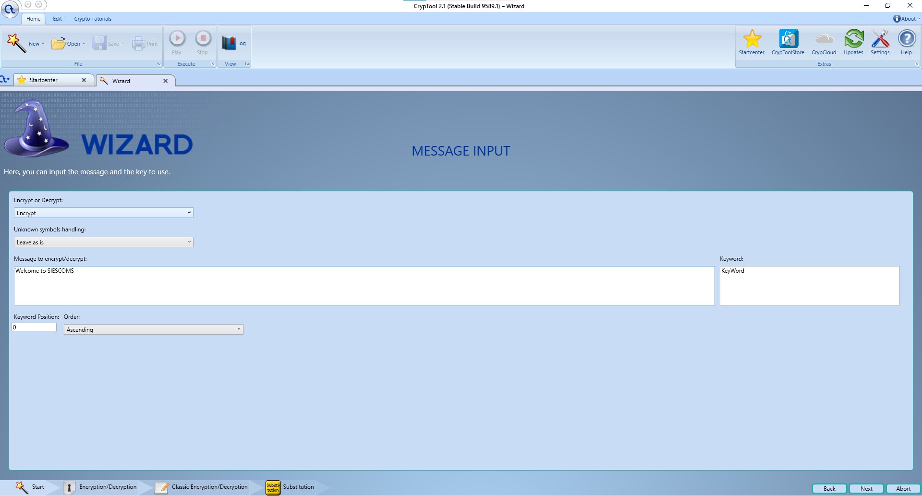

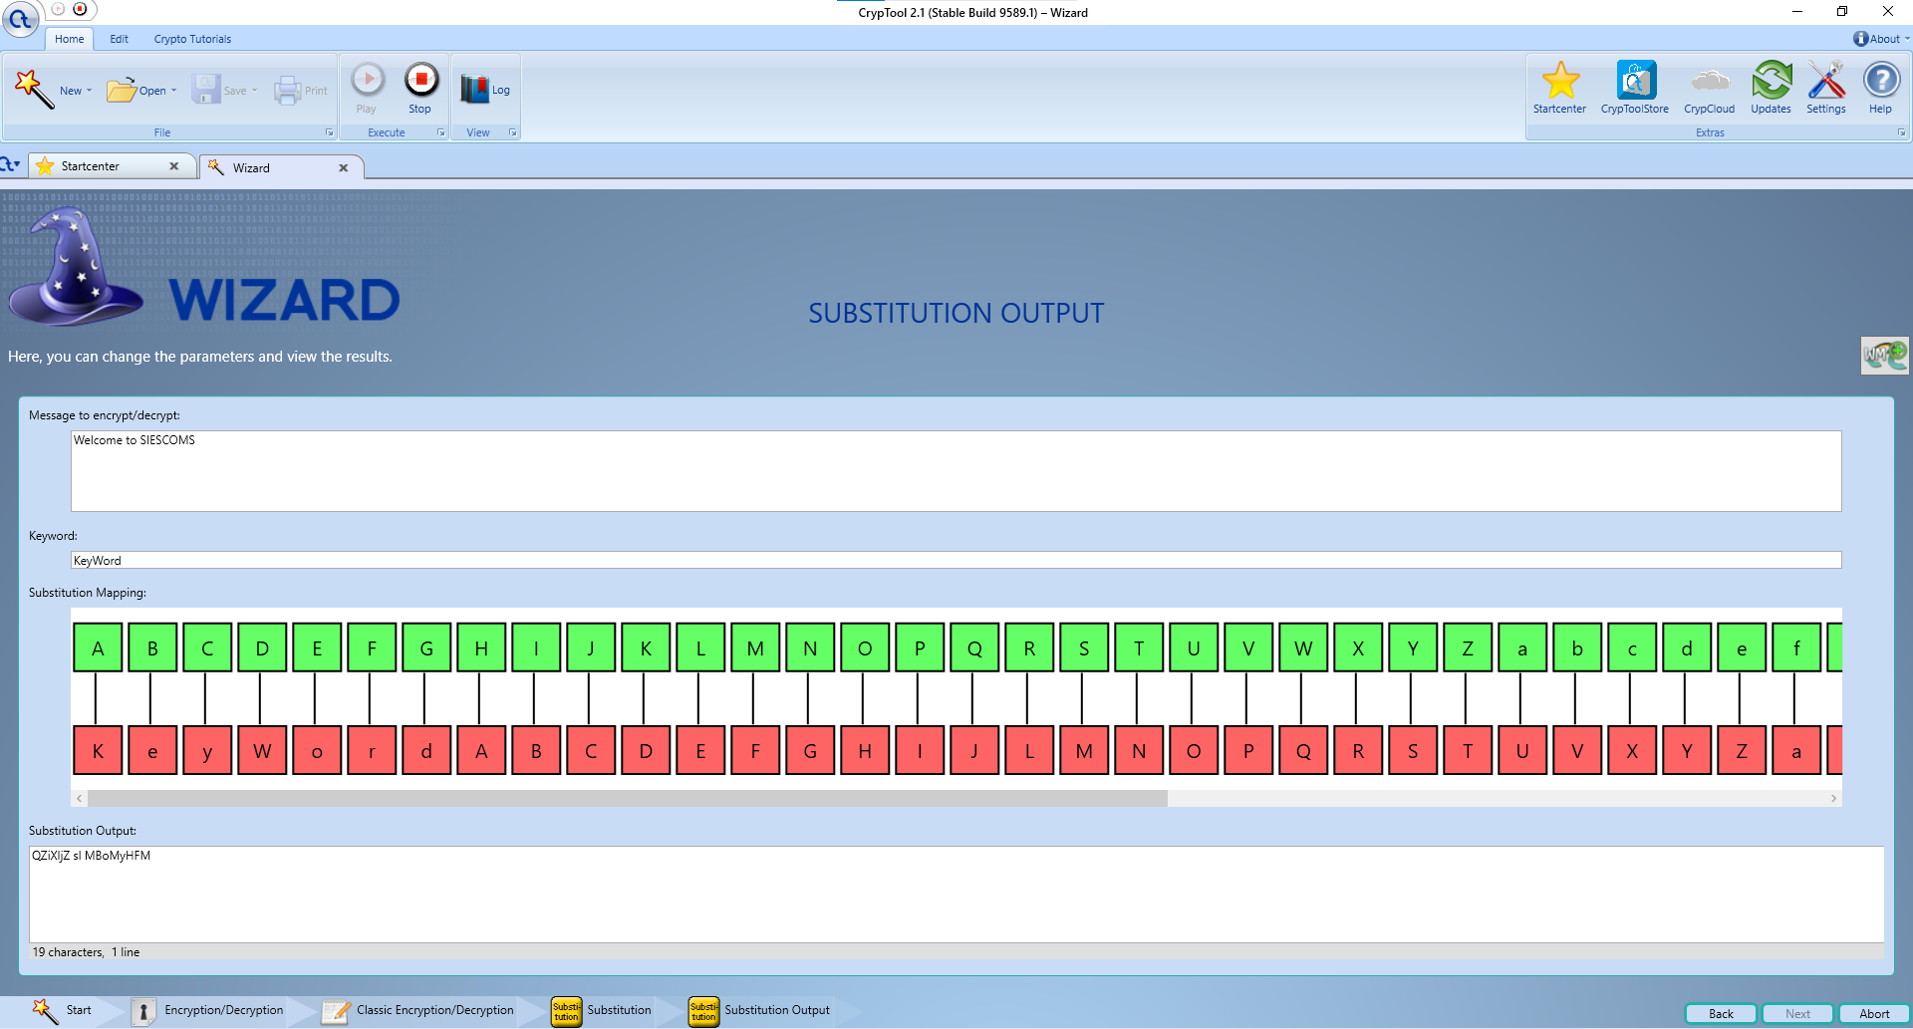

**Substitution cipher: decryption output**

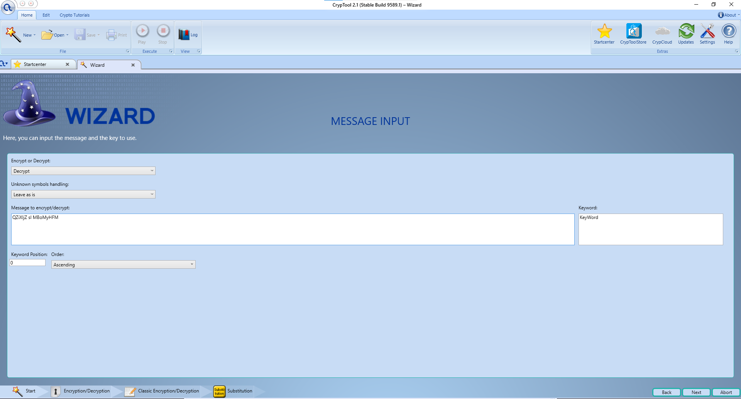

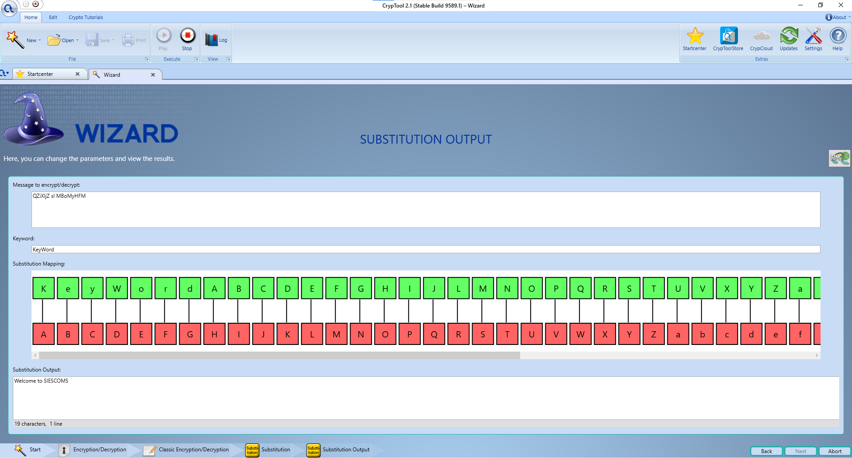

c) Playfair Cipher

**Select Substitution Cipher**

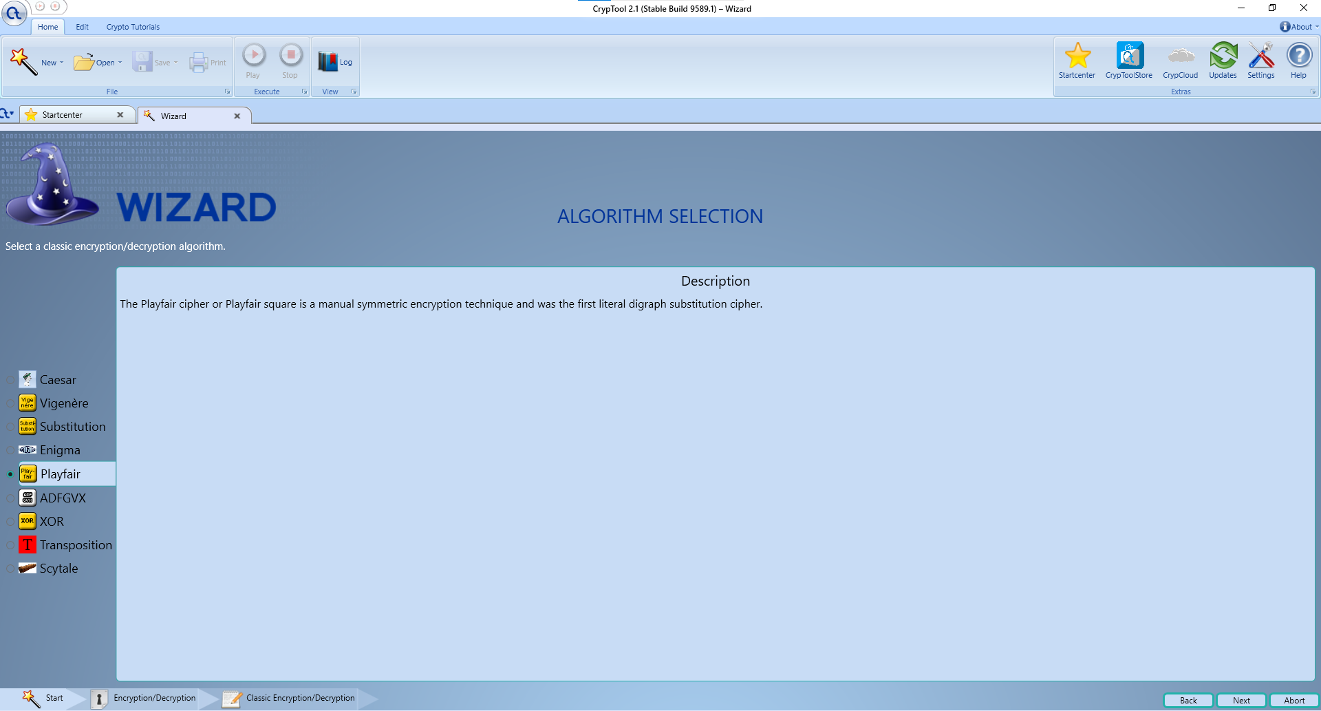

**Enter message in input-for eg. Hi how r u, select encrypt**

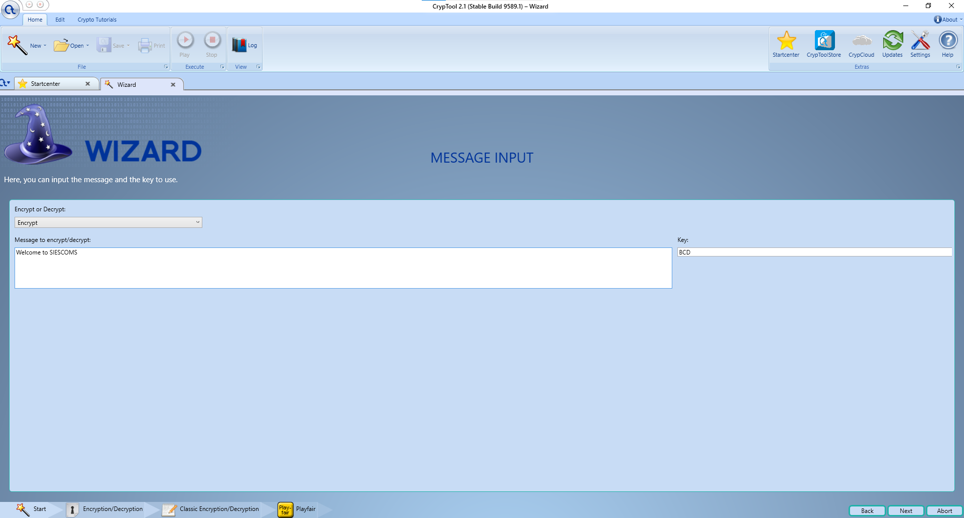

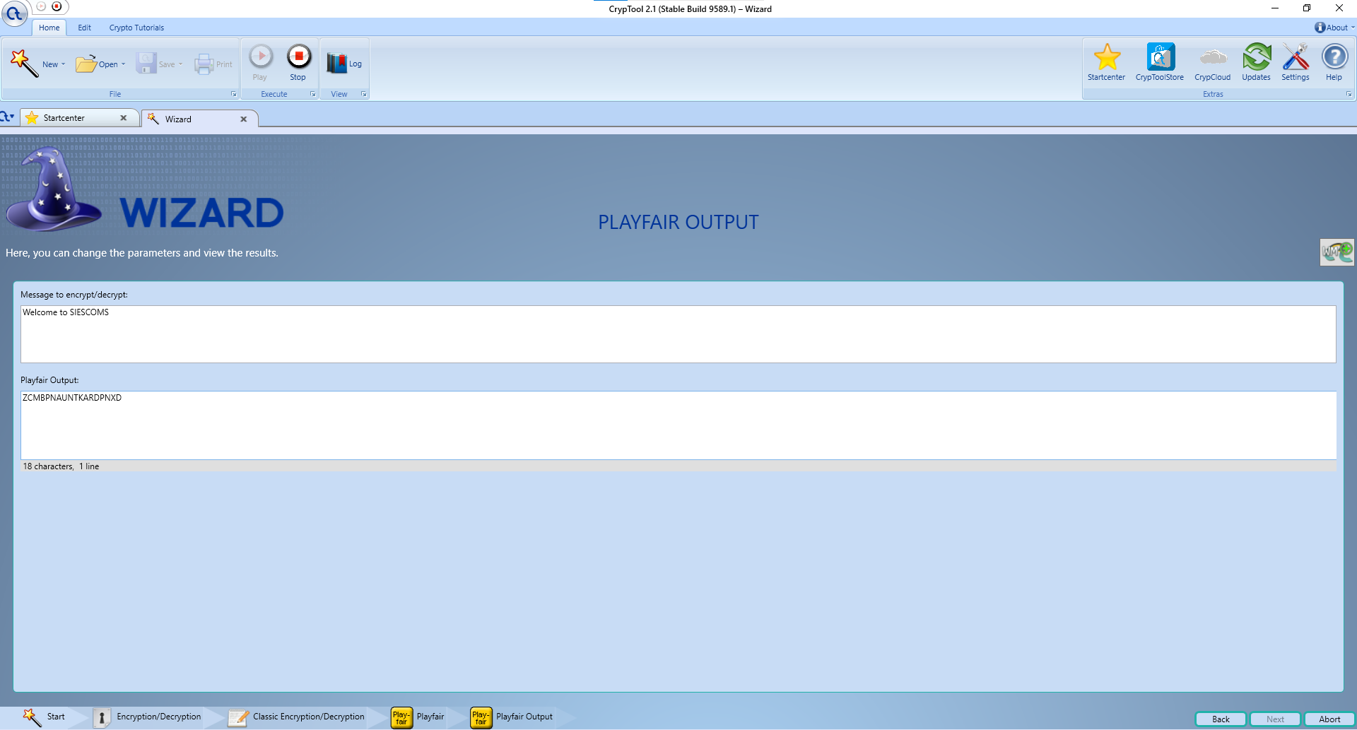

**Playfair cipher: decryption output**

